Job Description: Compliance Administrator

Line Manager/responsible to: Compliance and Conformance Manager

Responsible for: N/A

Salary: £18,500 - £20,000 PA, depending on qualifications held.

Who we are:

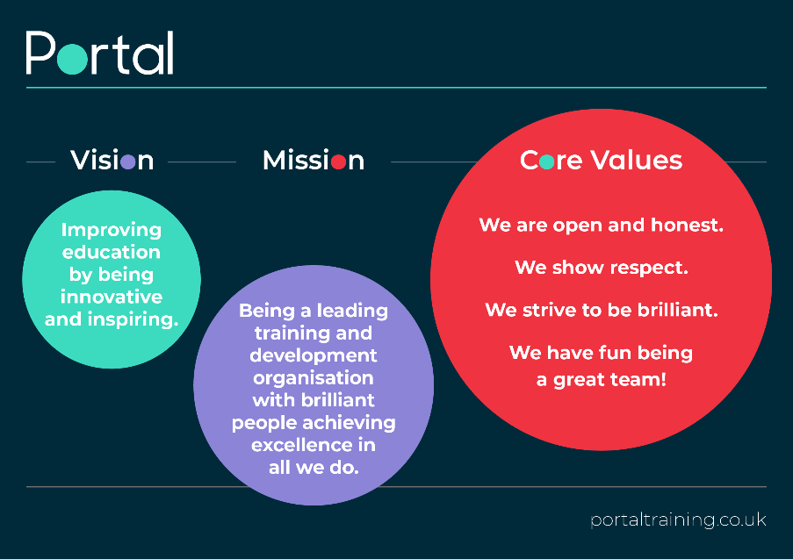

Summary of Role

Follow administration processes at Portal Training ensuring accurate data input, efficient filing systems and timely actioning of all work within the department thus meeting Welsh Government, Lead Provider, Awarding Organisation and internal deadlines.

Administration Duties
- Monitor and validate all starts submitted ensuring accuracy and compliance of all documents
- Complete an audit check on all learner reviews submitted through One File and update MIS system accordingly
- Accurately register all learners within the 8-week timeframe and update MIS
- Update MIS with any information which informs learner suspension
- Accurately claim learner certificates and close down learning activities on MIS
- Audit all documentation required to terminate a learner prior to processing on MIS
- Process any audit actions received from delivery team and update MIS
- Monitor learner provisional list to ensure timely claiming of Framework Certificate escalating any outstanding certificates over 4 weeks to Compliance Manager
- Attend weekly meetings with Compliance Manager discuss any Compliance concerns
- Audit and archive terminated learners in line with company procedure
- Ensure up to date knowledge of all MIS systems (Maytas, Vision and One File)
- Record any maladministration on the relevant report and discussed with Compliance Manager to identify solutions to prevent errors re-occurring
- Provide delivery team with advice and support regarding any Compliance documentation and queries
- Admin mailbox to be addressed ensuring no emails to go over 1 week

Office Duties and Information Security
- Maintain and manage Portal’s key register to ensure information security polices and processes are adhered to.
- Ensure that any requests for learner information requested by lead providers are transferred in a safe and secure manner.
- Ensure any learner files removed from secure filing areas are signed out, returned as agreed and held in a secure place whilst signed out.
- Ensure you transfer data in a secure manner either using Egress or password protected files and the data transfer log is updated when transferring any data deemed a risk.
- Ensure Portal office is well stocked at all times.
- Maintain inventory relating to general day to day stationery needs.

General Duties
- Update job knowledge by participating in educational opportunities for example: reading trade publications and attending networking events.
- Take part in any project work deemed necessary by Portal Training’s senior management team.
- Fully engage with and adhere to Portal Training’s company values.
- Embrace Portal Training’s strategies, polices and processes.
- Ensure that all your practices adhere to information security policies, procedures and legislation.
- Work as a team to ensure continuous quality improvements supporting the company’s journey to excellence.
- Keep outlook calendars up to date at all times.

Key Responsibilities: The above duties are not an exhaustive list and should be viewed as guidance. Your line manager or Portal’s Senior Management team may ask that you take part in additional duties in order to fully utilise your experience, skills and knowledge.

Key Performance Indicators 2020/2021
Measure | Performance Activity | Performance Indicators
Values | Demonstrated Core Values | (RAG) Green
Contract Compliance | All start validations are processed by freeze | 100%
 | Registrations to be processed within 8 weeks of learner start date | 100%
 | All qualifications to be claimed within one week of IQA claim request | 100%
 | All suspensions and terminations to be processed by Friday prior to freeze of month submitted | 100%

Person Specification:

Personal Qualities
- Excellent rapport building and people skills.
- Excellent communication skills both verbal and written.
- Personable with a proven track record of working with a diverse range of individuals.
- A highly self-motivated individual with a positive ‘can do’ attitude.
- Excellent time management and organisation skills.

Essential Experience and Skills
- Experience in the use of the Maytas MIS – to be able to navigate and update information.
- Experience in working within Work Based Learning – knowledge & understanding of compliance rules.
- Experience of working within an administration role.
- Excellent communication skills, both verbal and written.
- A proven track record in forging and maintain excellent working relationships.

Desirable Experience and Skills
- Business Administration and/or Customer Service Qualification.
- Welsh speaking.

